**Password Based Door Lock System**

**Description:**

Password Based Door Lock System using 8051 microcontrollers in which a secure password will act as a door unlocking system. Such an automatic lock system consists of electronic control assembly, which controls the motor (stepper motor connected to the door) through a password. It is a simple embedded system with input from the keypad and the output being actuated accordingly.

This system demonstrates a Password based Door Lock System using 8051 microcontrollers, wherein once the correct code or password is entered, the door is opened for 5 seconds and the concerned person is allowed access to the secured area. After 5 seconds door will be closed. Again, if another person arrives, it will ask to enter the password. If the password is wrong, then door would remain closed, denying access to the person. Password can be any number of digits for a user (Not less than four). Every User is given three attempts and if password is not correct alarm (here you can use Led blink as an alarm) must intimate security team.

Also count the number of people entered the secured area. Max allowed people are 10 at a time. To know the person is entered, two buttons are used at two different points. One button is used strictly for the entrance and the other for exit. Every person entering the building must push entrance button to mark entry. Door is supposed to open when a person wants to leave so exit button helps unlocking.

Door (Output motor) is connected at **p1.0**. You are to show the door locking and unlocking through motor output only. Show following output on the LCD.

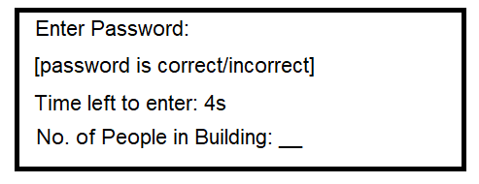

**Note:** If the person has entered but the timer is still running, reset the timer and close the door. If the person does not enter the building in given time, he has to enter the password again and system should not count that person until entered.